Day 14 - 4th July - 113195064 - Bondili Bhavya Charitha

TASK:1 - Create a custom node, add elements to it and traverse it.
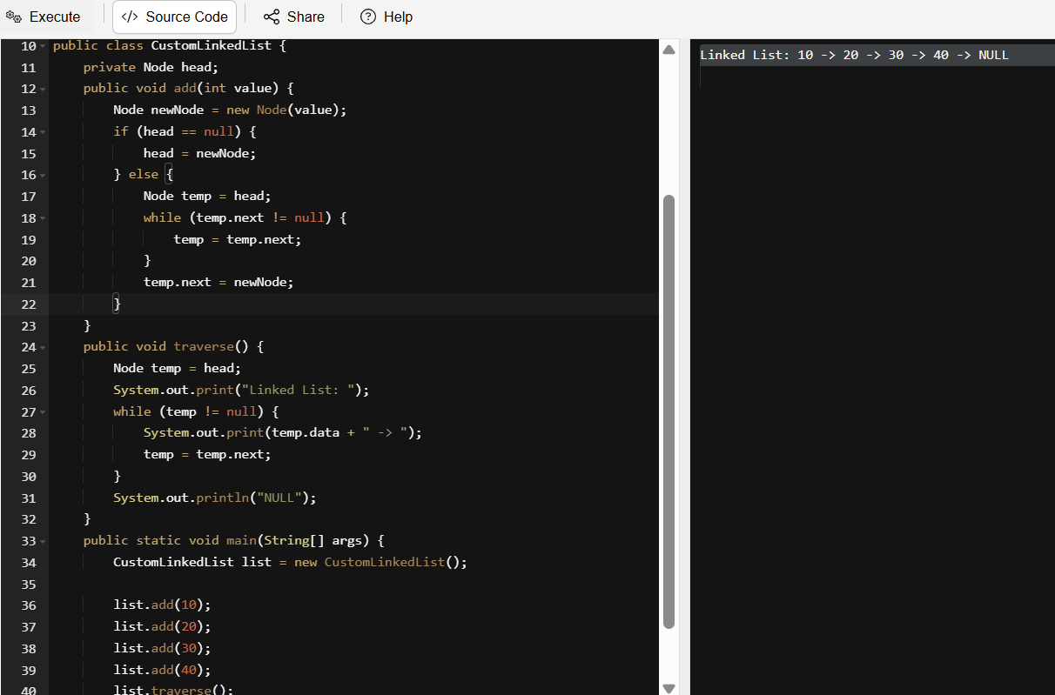

TASK:2 - What do you understand by traversing a linked list?
Traversing a linked list means systematically visiting each node in the list – one by one – to access the data stored in them. Traversing is the process of starting from the head (first node) then moving through each node using the next pointer (or previous in a doubly linked list) after then performing an operation (like searching, or modifying data) lastly stopping when you reach the end (i.e., null in singly linked lists or back to head in circular lists).

TASK:3 - Create a Circular Linked list using Task 1 Singly linked list.
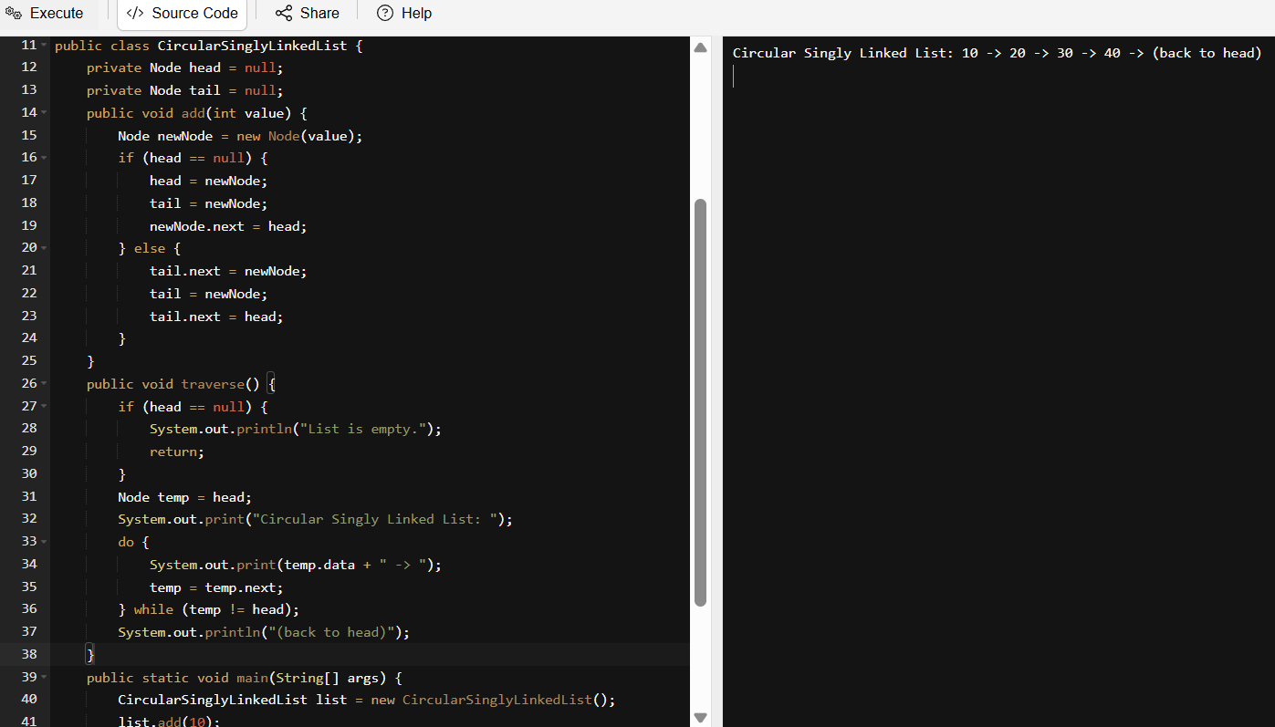

TASK:4 - Delete a node in the circular linked list
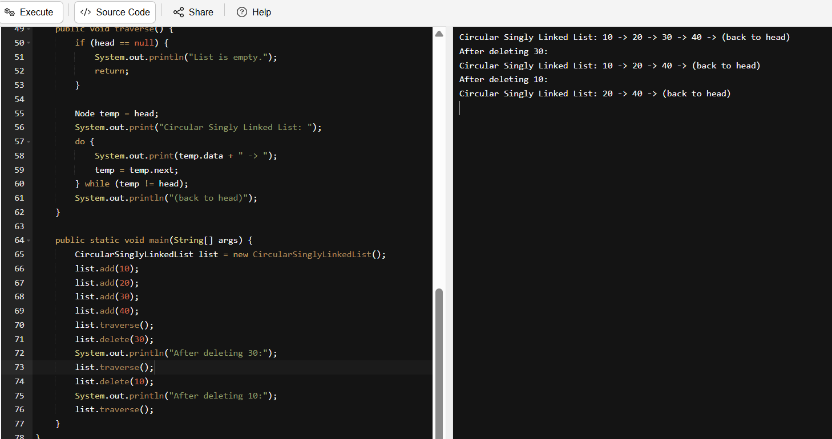
class Node {
int data;
Node next;

Node(int data) {
this.data = data;
this.next = null;
}
}
public class CircularSinglyLinkedList {
private Node head = null;
private Node tail = null;
public void add(int value) {
Node newNode = new Node(value);
if (head == null) {
head = newNode;
tail = newNode;
newNode.next = head;
} else {
tail.next = newNode;
tail = newNode;
tail.next = head;
}
}
public void delete(int value) {
if (head == null) return;
Node current = head;
Node prev = tail;
do {
if (current.data == value) {
if (current == head) {
head = head.next;
tail.next = head;
} else if (current == tail) {
tail = prev;
tail.next = head;
} else {
prev.next = current.next;
}
if (head == tail && head.data == value) {
head = tail = null;
}
return;
}
prev = current;
current = current.next;
} while (current != head);
}
public void traverse() {
if (head == null) {
System.out.println("List is empty.");
return;
}

Node temp = head;
System.out.print("Circular Singly Linked List: ");
do {
System.out.print(temp.data + " -> ");
temp = temp.next;
} while (temp != head);
System.out.println("(back to head)");
}

public static void main(String[] args) {
CircularSinglyLinkedList list = new CircularSinglyLinkedList();
list.add(10);
list.add(20);
list.add(30);
list.add(40);
list.traverse();
list.delete(30);
System.out.println("After deleting 30:");
list.traverse();
list.delete(10);
System.out.println("After deleting 10:");
list.traverse();
}
}

TASK:5 - Create a stack and pop the element also print the popped element.
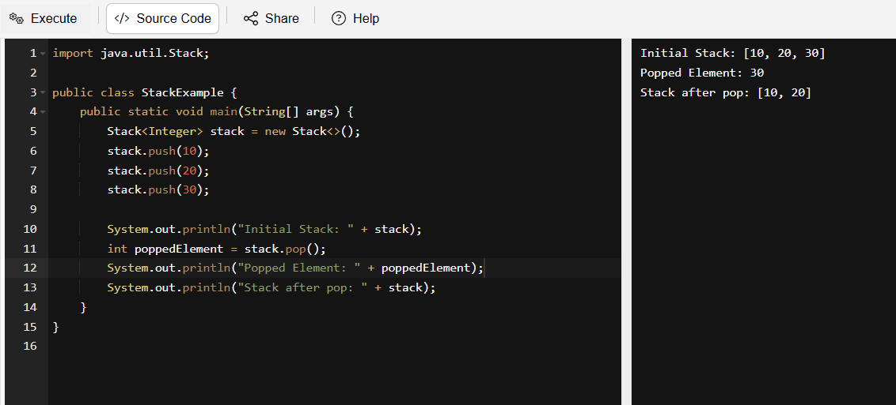

TASK:6 - Find an element in the stack and display the position.
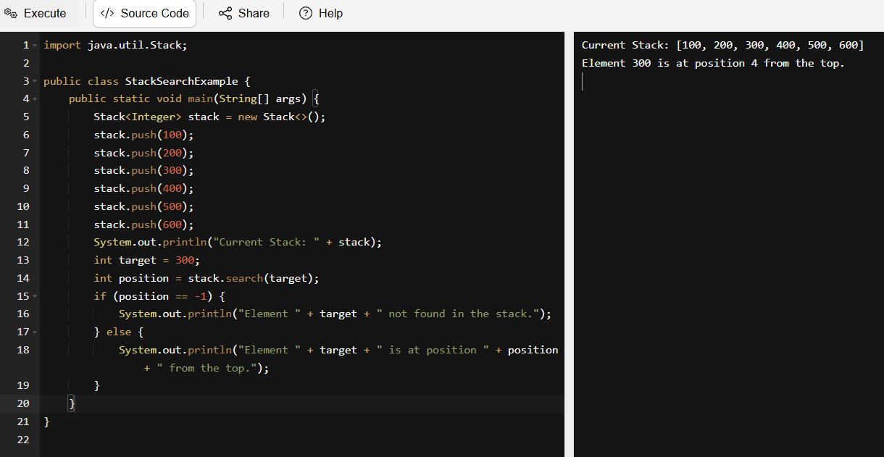

TASK: 7 - Peek the element and print it.
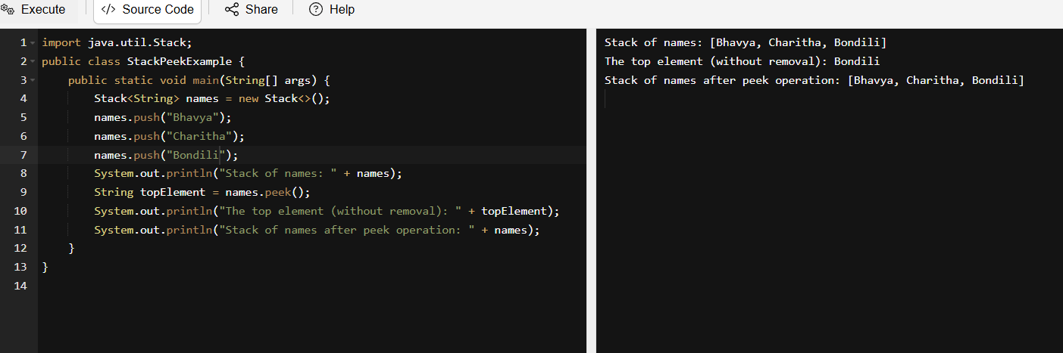
TASK:8 - Check if the stack is empty or not?
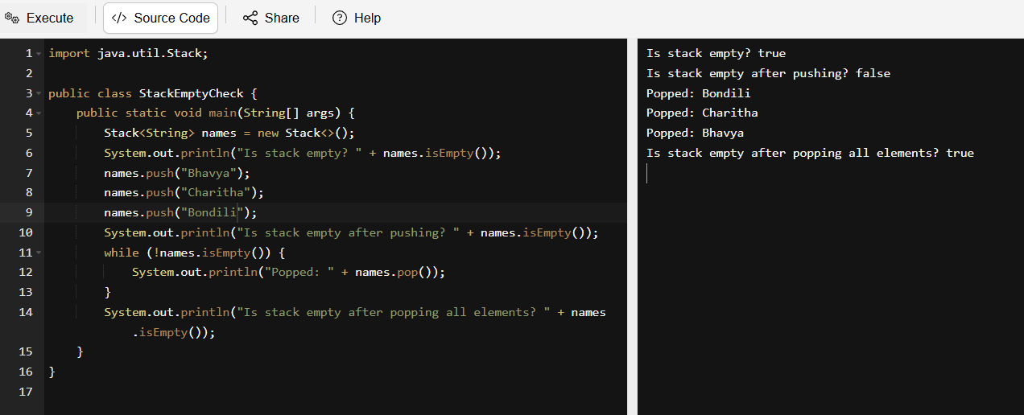
TASK:9 - What are the methods of the stack class. List them down.
Method Description
push(E item) - Adds an item to the top of the stack.
pop() - Removes and returns the top item from the stack.
peek() - Returns the top item without removing it.
empty() - Checks if the stack is empty.
search(Object o) - Returns the 1-based position of an item from the top, or -1 if not found.
size() - Returns the number of elements in the stack.
isEmpty() - Returns true if the stack has no elements.
clear() - Removes all elements from the stack.
iterator() - Returns an iterator over the elements in the stack.
contains(Object o) - Checks if the stack contains the specified element.
get(int index) - Retrieves the element at the specified index.
set(int index, E el) Replaces the element at the specified index with the given element.

TASK:10 –
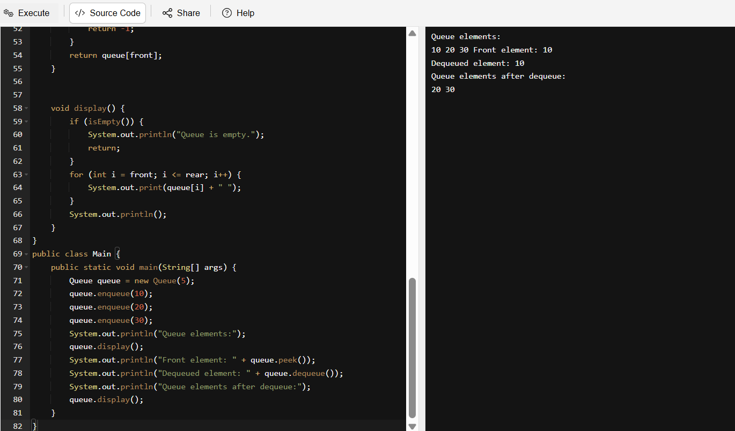

Home Work Task: Converting stack and deque into a lists and printing their elements in java using streams
